

BCSE417L – MACHINE VISION LAB

EXPERIMENT 8: Implementing Watershed and Graph Cut Algorithms for Image Segmentation

SUBMITTED BY-
22BAI1118 – Mayank Raj

SUBMITTED TO-
Trilok Nath Pandey
Date: 07/03/2024

Image Segmentation for Brain Tumor Detection: A Comparative Study
1. Introduction
This report presents a comparative analysis of two image segmentation techniques - the Watershed algorithm and the Graph Cut algorithm - for brain tumor detection in MRI scans. The study includes preprocessing steps to enhance image quality and improve segmentation results.
Input image:
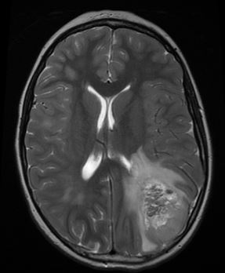

2. Methodology
2.1 Preprocessing
Image preprocessing is essential for enhancing the quality of input images before segmentation. The following preprocessing steps were implemented:
- Gaussian Smoothing: A Gaussian blur with kernel size (5,5) was applied to reduce noise while preserving important edge information.
- Contrast Limited Adaptive Histogram Equalization (CLAHE): CLAHE was implemented with a clip limit of 2.0 and tile grid size of (8,8) to enhance contrast and improve visibility of tumor regions.
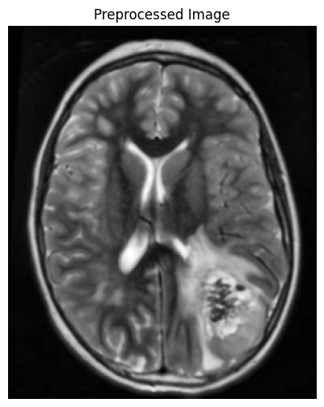

2.2 Watershed Algorithm
The Watershed algorithm treats the image as a topographic surface where bright pixels represent high elevations and dark pixels represent low elevations. The implementation involved the following steps:
- Thresholding: Otsu's thresholding was applied to convert the preprocessed image into a binary image.
- Morphological Operations: Opening operation was performed to remove small noise and refine the tumor region.
- Distance Transform: The distance transform was computed to identify the foreground regions.
- Marker Creation: Foreground and background markers were generated based on the distance transform.
- Watershed Segmentation: The watershed transform was applied using the markers and gradient information.
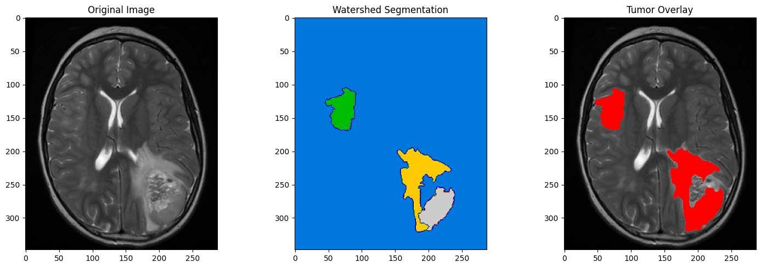
2.3 Graph Cut Algorithm
The Graph Cut algorithm formulates image segmentation as a graph partitioning problem. Key steps include:
- Graph Construction: Creating a graph representation of the image where pixels are nodes and edges represent pixel relationships.
- Energy Function Definition: Defining data terms (pixel-label costs) and smoothness terms (boundary costs).
- Max-Flow/Min-Cut: Performing max-flow/min-cut to obtain the optimal segmentation by minimizing the energy function.
- Foreground-Background Separation: Generating a binary mask separating tumor regions from healthy brain tissue.
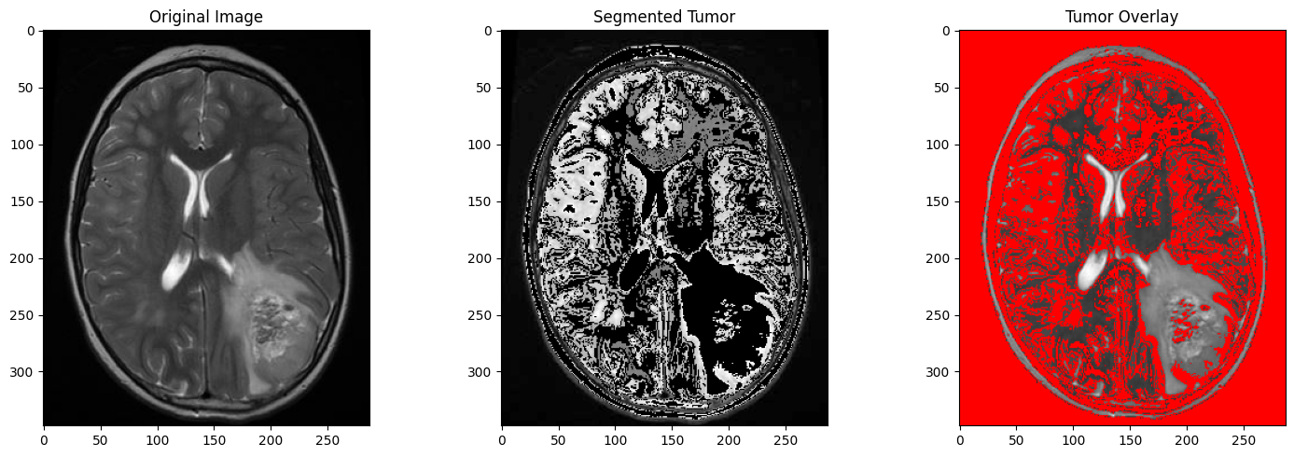
3. Results and Analysis
3.1 Segmentation Results
Both algorithms successfully identified and segmented the tumor regions in the MRI scan.
3.2 Analysis
The Watershed algorithm demonstrated effective performance in segmenting the brain tumor regions:
- Boundary Precision: The watershed transform provided well-defined boundaries between the tumor and surrounding brain tissue.
- Sensitivity to Intensity Variations: The algorithm successfully identified regions with distinctive intensity patterns characteristic of tumors.
- Post-processing Effects: The morphological operations effectively refined the segmentation by removing noise and smoothing boundaries.

4. Comparative Analysis
Aspect | Watershed Algorithm | Graph Cut Algorithm
Accuracy | Good for well-defined boundaries | Better for complex, inhomogeneous regions
Sensitivity to Noise | Higher sensitivity | More robust
Computational Efficiency | Generally faster | More computationally intensive
Parameter Tuning | Requires careful marker selection | Needs tuning of energy function parameters

5. Advantages and Limitations
5.1 Watershed Algorithm
Advantages:
- Produces continuous boundaries along region edges
- Effective at separating touching objects with distinct boundaries
- Computationally efficient compared to global optimization methods
- Integrates well with other morphological image processing techniques
Limitations:
- Tendency for over-segmentation, particularly in noisy images
- Quality of segmentation is highly dependent on the initial markers
- May struggle with low contrast or gradual intensity transitions
- Sensitive to local minima in the gradient image

5.2 Graph Cut Algorithm
Advantages:
- Globally optimal solution for binary segmentation
- Incorporates both region and boundary information
- Robust to noise and intensity variations
- Better handling of inhomogeneous regions
Limitations:
- Computationally expensive for large images
- Requires careful selection of energy function parameters
- May struggle with thin structures or complex topologies
- Binary segmentation requires extensions for multi-label problems
6. Conclusion
This study demonstrates the effectiveness of both Watershed and Graph Cut algorithms for brain tumor segmentation in MRI images. The Watershed algorithm provides computationally efficient segmentation with good boundary delineation, while the Graph Cut algorithm offers more robust handling of complex tumor regions.
For brain tumor segmentation, the choice between these algorithms depends on specific requirements:
- The Watershed algorithm is preferable when computational efficiency and clear boundary detection are priorities.
- The Graph Cut algorithm may be more suitable for complex cases with inhomogeneous tumor regions and significant noise.
The preprocessing steps, including Gaussian smoothing and CLAHE, significantly improved the segmentation quality for both algorithms by enhancing image contrast and reducing noise.
Future work could explore hybrid approaches combining the strengths of both algorithms or incorporating deep learning techniques for more accurate and automated tumor segmentation.

